How To Purchase A Membership Online

- Go to www.shredattheshed.net (NOTE: on your phone memberships are under the lines on the right hand corner.)
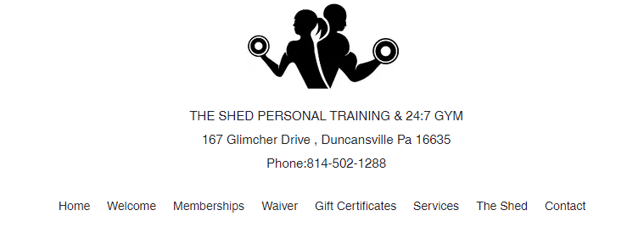

- After you select your membership you will get a WELCOME EMAIL create your LOGIN information.
- Go to the APP STORE on your PHONE download the RHINOFIT APP
- LOGIN to the APP select YOUR NAME at the top of the APP . SELECT BARCODE
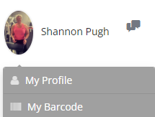
- SCAN THE BARCODE AT THE DOOR THE DOOR WILL OPEN.

